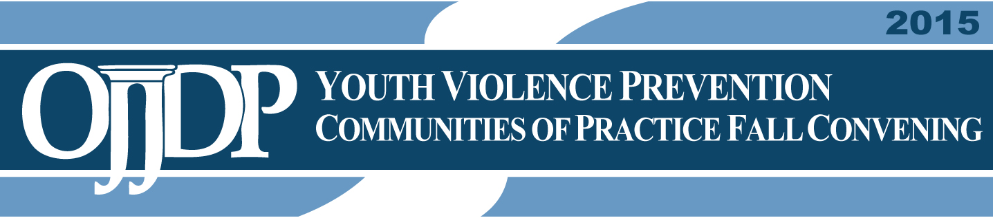

Wednesday, November 18; Day 2. YVP Communities of Practice
Unless otherwise listed, all events will take place in the Holiday Ballroom 1–3 (Second Floor)

Defending Childhood

7:30 a.m. Registration Open
Holiday Ballroom Foyer (Second Floor)

8:30 a.m. Shared Frameworks: Opening Remarks
A discussion focusing on the overarching framework of the three OJJDP Initiatives, reiterating the purpose of the conference as it relates to all programs.

Introductions: Eugene Schneeberg, Director, U.S. Department of Justice, Faith-Based Shared Learning Collaborative

Panelists: The Hon. Karol V. Mason, Assistant Attorney General, Office of Justice Programs, U.S. Department of Justice
Melissa Rogers, Executive Director, White House Office of Faith-Based and Neighborhood Partnerships
Leana Wen, M.D., Health Commissioner, City of Baltimore, Md.
Kevin Davis, Commissioner, Baltimore Police Dept., Baltimore, Md.
9:00 a.m. Racial Justice and Equality Workshop
Latrobe Room (First Floor)
Participants will discuss and identify challenges/successes/strategies they have confronted or seen in their own communities.

As a follow-up to a session and Webinars with James Bell and Tuesday’s Equal Justice Initiative training, participants will be provided with an opportunity to engage in a deeper discussion on the issues of

      - Law enforcement/community relations
      - Race, healing and justice
      - Equity in child serving systems

Moderator: Catherine Pierce, Senior Advisor to the Administrator, Office of Juvenile Justice and Delinquency Prevention, U.S. Department of Justice
10:45 a.m. Break

11:00 a.m. A Culturally-Based Approach to Healing from Trauma and Violence
Latrobe Room (First Floor)
Participants will learn about trauma response, intervention and healing from a
Sicangu Lakota cultural approach.

Presenters: Vikki Eagle Bear, Project Director, Rosebud Sioux Tribe Defending Childhood, Rosebud, S.D.
Lila Kills In Sight, Faith-Based Representative, Rosebud Sioux Tribe Defending Childhood, Rosebud, S.D.
Recommendations From the American Indian/Alaska Native Advisory Committee (AI/AN) Task Force on Children Exposed to Violence (CEV)
To report on the activities/progress related to the recommendations from the AI/AN Task Force on CEV.

Presenter/Moderator: Marilyn Zimmerman, Director, National Native Children’s Trauma Center Institute for Educational Research and Service, University of Montana, Missoula, Mont.

12:30 p.m. Keynote Lunch

Working Lunch With Kevin Grant, Violence Prevention Coordinator, City of Oakland, and Owner, Kevin Grant Consulting
All attendees are invited to participate. (Participants will be responsible for purchasing their own lunch. A box lunch priced at government per diem will be available for purchase outside of the Ballroom.)

1:45 p.m. Discussion on ACEs, Trauma, and Violence
Latrobe Room (First Floor)
Participants will follow up their conversation about ACEs, trauma, and violence and provide an opportunity to engage in deeper discussion on
      - Lessons learned about these three issues
      - Similarities and differences
      - Guidance to the larger national audience

Moderator: Lonna Davis, Director, Children and Youth, Futures Without Violence

3:00 p.m. Sustainability Workshop
Latrobe Room (First Floor)
Participants will review and provide feedback on a draft sustainability framework and assessment tool, focusing on strategic planning for long-term success in supporting local efforts and fundamentally changing the way youth violence is addressed.

Moderators: Casey Corcoran, Program Director, Futures Without Violence
Lynn Tiede, Senior Consultant, Mainspring Consulting
Barbara Langford, Founding Partner, Mainspring Consulting

4:00 p.m. All Groups

Integrating Faith and Community-Based Approaches Into Local YVP Efforts
This session will begin with a moderated discussion with representatives from the Faith, Defending Childhood, and CBVP communities to review key takeaways from the day, and will allow for sites to discuss with their faith leaders how to integrate their work after the convening. All sites will use an action planning tool to discuss what strategies would be incorporated into their sites’ plans.

Moderators: Eugene Schneeberg, Director, U.S. Department of Justice, Faith-Based Shared Learning Collaborative
Kristen Kracke, Senior Program Manager, Office of Juvenile Justice and Delinquency Prevention, U.S. Department of Justice
Carmen Santiago Roberts, Program Manager, Office of Juvenile Justice and Delinquency Prevention, U.S. Department of Justice

5:15 p.m. Adjournment

